Prototype Cost Analysis Report Lab 10
Brady Adams, Jaiden Medina

Background:
The system that we are using throughout this lab consists of a circular printed circuit board populated with an STM32L432 microcontroller and a TSL237 light sensor, put inside a custom 3D-printed enclosure with a laser-cut clear acrylic lid. The enclosure was designed in Fusion 360 and includes integrated standoffs for PCB mounting, sealing features, and an external access point for programming and communication.
For estimating realistic prototype costs, the websites that were used included Macrofab, Shapeways, and Sculpteo. Printed circuit board fabrication and assembly were quoted using the MacroFab platform. The enclosure base was quoted using Shapeways’ 3D printing service, and the clear acrylic lid was quoted using Sculpteo’s laser cutting service.

Prototype Cost Analysis:
The prototype costs were estimated for quantities 5, 10, 15, and 20 units to evaluate how scaling production affects total system cost.
MacroFab was used to estimate the cost of producing printed circuit boards. The cost per PCB decreases significantly as quantity increases due to tooling amortization and bulk component pricing.
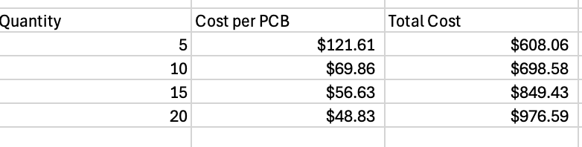
For a quantity of 5 boards, the cost per PCB is $121.61, resulting in a total PCB cost of $608.06. As quantity increases, the cost per unit drops steadily, reaching $48.83 per PCB at a quantity of 20 boards, with a total cost of $976.59. This demonstrates the strong impact of fixed setup costs at low production volumes and the efficiency gains achieved by ordering multiple units at once.
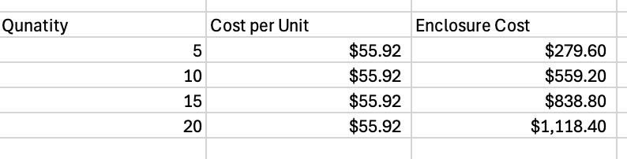
The enclosure cost per unit remains constant across all quantities at $55.92 per enclosure. This reflects the nature of additive manufacturing, where each part is printed individually with minimal cost reduction from increased quantities. As a result, enclosure costs scale linearly with quantity. For example, 5 enclosures cost $279.60, while 20 enclosures cost $1,118.40. Although convenient for small batches, this method becomes a significant contributor to total system cost as production volume increases.
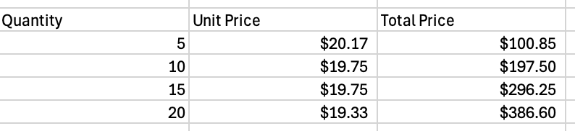
The unit price for the lid shows a small reduction as quantity increases, decreasing from $20.17 at 5 units to $19.33 at 20 units. This modest price reduction reflects more efficient material usage and batching during fabrication. Overall, the lid contributes a relatively small portion of total system cost compared to the PCB and enclosure but still benefits slightly from increased production quantities.
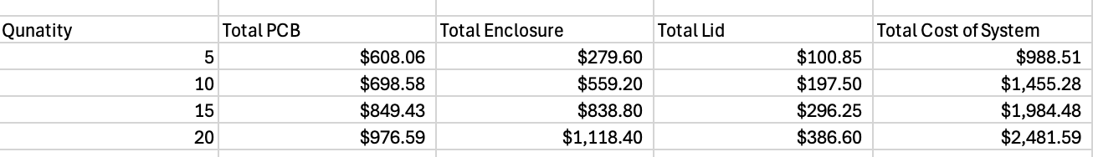
The total prototype cost was calculated by summing the PCB, enclosure, and lid costs. For a quantity of 5 systems, the total cost is $988.51. As the quantity increases to 20 systems, the total cost rises to $2,481.59. While total cost increases with quantity, the cost per system decreases, driven primarily by lower PCB unit pricing at higher volumes.
This breakdown highlights that the PCB dominates cost reduction at increased quantities, while the enclosure remains a relatively fixed expense per unit.

3. Conclusion and Cost Reduction Recommendations:
Based on the cost analysis, the populated PCB is the most significant cost driver at low volumes but also offers the greatest opportunity for cost reduction through increased production quantity. Ordering larger batches allows fabrication and assembly overhead to be spread across more units, substantially reducing the per-unit PCB cost.
In contrast, the 3D-printed enclosure does not benefit from economies of scale and becomes a dominant cost factor as quantity increases. For larger production volumes, transitioning from 3D printing to a molded or simpler enclosure design could significantly reduce overall system cost. Similarly, while the laser-cut lid cost is comparatively low, small savings can still be achieved through batch fabrication.
Overall, this analysis demonstrates the tradeoffs between flexibility and cost in prototype manufacturing and provides insight into how design and production choices impact total system cost.

